Project Design Phase
Solution Architecture

Date | 15 February 2026
Team ID | SWTID-2026-5878
Project Name | Automating Data Import and Relationship Mapping using Import Sets and Dot Walking
Maximum Marks | 4 Marks

Solution Architecture Diagram:
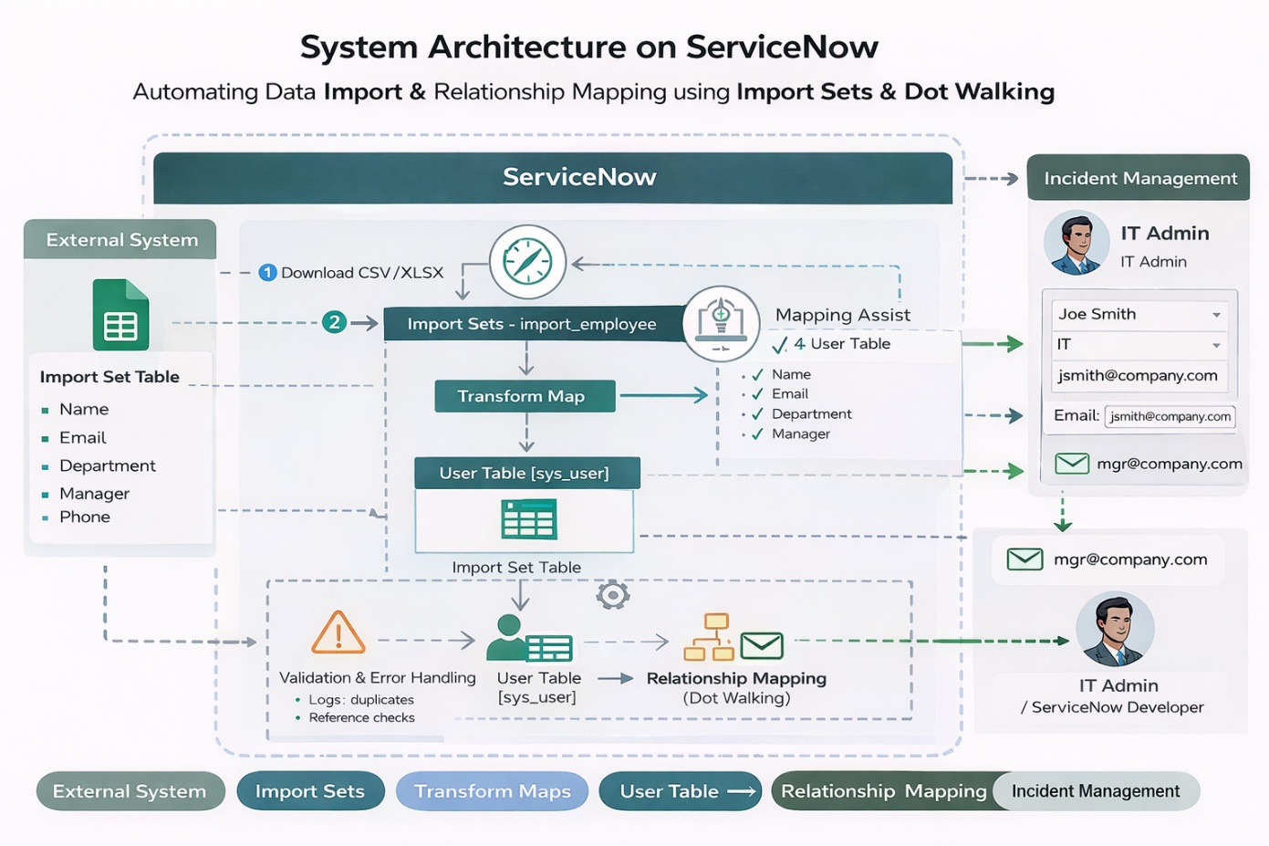
Figure 1: Architecture and data flow of the ServiceNow Import Sets & Dot-Walking for Managing Relationships and Automating Data Import

